Chemistry project

Hydrocarbons and their uses

Name: Negar Abelehkoub

Class: 11D

Date: 12/04/2023

**Hydrocarbon Types and Uses**

Hydrocarbons are organic compounds composed of carbon and hydrogen atoms. They are the principal constituents of crude oil and natural gas, and they serve as the primary source of energy for modern industrial society. Hydrocarbons are used in various industries for different purposes, including fuel, lubrication, plastics, and chemicals. This paper provides an overview of hydrocarbons, their types, sources, and uses.

**Types of Hydrocarbons:**

Hydrocarbons are classified into two broad categories: aliphatic and aromatic. Aliphatic hydrocarbons are linear or branched chains of carbon atoms, while aromatic hydrocarbons are cyclic structures that contain a ring of carbon atoms. Aliphatic hydrocarbons are further divided into two subcategories: saturated and unsaturated. Saturated hydrocarbons contain only single bonds between carbon atoms, while unsaturated hydrocarbons contain double or triple bonds.

**Shapes of hydrocarbons**

Hydrocarbons are molecules consisting of carbon and hydrogen atoms. The shapes of hydrocarbons depend on the number and arrangement of these atoms in the molecule. Here are some common shapes of hydrocarbons:

* **Linear**
* **Branched**
* **Cyclical**
* **Aromatic**
* **Alkenes and Alkynes**
* **Linear**: In linear hydrocarbons, the carbon atoms are arranged in a straight line. Examples of linear hydrocarbons include ethane (C2H6)propane(C3H8), and butane (C4H10).

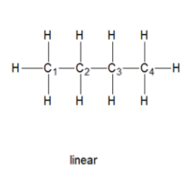

* **Branched**: In branched hydrocarbons, the carbon atoms are arranged in a non-linear pattern, with some carbon atoms branching off from the main chain. Examples of branched hydrocarbons include isobutane (C4H10), isopentane (C5H12), and neopentane (C5H12).

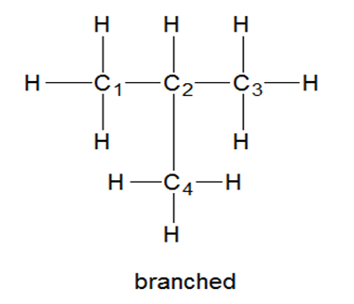

* **Cyclical**: In cyclical hydrocarbons, the carbon atoms are arranged in a closed ring. Examples of cyclical hydrocarbons include benzene (C6H6), cyclohexane (C6H12), and cyclooctane (C8H16).

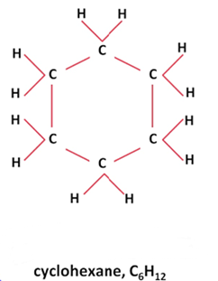

* **Aromatic**: Aromatic hydrocarbons are a subset of cyclical hydrocarbons that contain a special type of ring called an aromatic ring, which is made up of alternating double and single bonds between carbon atoms. Examples of aromatic hydrocarbons include benzene (C6H6), toluene (C7H8), and naphthalene (C10H8).

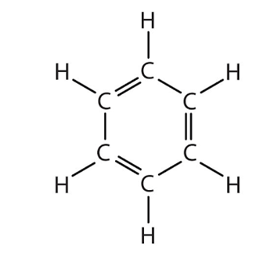

* **Alkenes**: Alkenes are hydrocarbons that contain at least one double bond between carbon atoms. The double bond causes a kink in the carbon chain, giving alkenes a distinctive shape. Examples of alkenes include ethene (C2H4), propene (C3H6), and butene (C4H8).

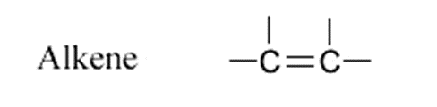

* **Alkynes**: Alkynes are hydrocarbons that contain at least one triple bond between carbon atoms. The triple bond causes an even greater kink in the carbon chain than a double bond, giving alkynes a distinctive shape. Examples of alkynes include ethyne (C2H2), propyne (C3H4), and butyne (C4H6).



**Sources of Hydrocarbons:**

The primary source of hydrocarbons is crude oil, a naturally occurring liquid found in underground reservoirs. Crude oil is composed of a mixture of hydrocarbons with varying molecular weights and structures. Natural gas, another source of hydrocarbons, is a mixture of gases, including methane, ethane, propane, and butane. Natural gas is often found in association with crude oil deposits or in underground reservoirs on its own.

**Uses of Hydrocarbons:**

Hydrocarbons are used in various industries for different purposes. The most common use of hydrocarbons is as fuel, both for transportation and for generating electricity. Hydrocarbons are also used as lubricants in machinery to reduce friction and wear. In addition, hydrocarbons are used as raw materials for the production of plastics, chemicals, and other products.

* **Fuel**:

Hydrocarbons are the primary source of energy for modern industrial society. They are used as fuel for transportation, including cars, trucks, ships, and airplanes. Hydrocarbons are also used to generate electricity in power plants. The most common hydrocarbon fuels are gasoline, diesel, and natural gas.

Gasoline is a mixture of hydrocarbons with a boiling range of 30-200°C. It is the most commonly used fuel for cars and light trucks. Diesel fuel, on the other hand, is a heavier hydrocarbon with a boiling range of 180-360°C. It is used primarily for heavy-duty trucks and buses. Natural gas, a mixture of methane and other hydrocarbons, is used as fuel for power plants and as a heating fuel for homes and businesses.

* **Lubricants**:

Hydrocarbons are used as lubricants in machinery to reduce friction and wear. Lubricants are used in a wide range of industries, including automotive, aerospace, and manufacturing. The most common hydrocarbon lubricants are mineral oils, which are derived from crude oil. Mineral oils are used as lubricants in engines, gearboxes, and hydraulic systems. They are also used as base oils for the production of synthetic lubricants. Synthetic lubricants are manufactured from hydrocarbons using chemical processes. They offer superior performance compared to mineral oils, including better viscosity control, higher oxidation resistance, and better low-temperature performance.

* **Plastics**:

Hydrocarbons are used as raw materials for the production of plastics. Plastics are synthetic materials made from polymers, which are long chains of repeating units. The most common polymers used in the production of plastics are polyethylene, polypropylene, and polyvinyl chloride. Polyethylene is a thermoplastic polymer made from ethylene monomers. It is used to make a wide range of products, including packaging films, plastic bags, and bottles. Polypropylene, another thermoplastic polymer, is used to make products such as packaging.In conclusion, hydrocarbons are an incredibly important class of molecules with a wide range of applications in energy production, chemical manufacturing, and pharmaceuticals. However, they are not without their drawbacks, including environmental concerns such as pollution and climate change. As such, it is crucial to continue researching and developing sustainable alternatives to hydrocarbons to reduce their negative impact on the environment and human health.

Fortunately, there are many promising alternatives to hydrocarbons that are being explored, including renewable energy sources like solar and wind power, as well as biofuels, which can be produced from organic materials like algae or agricultural waste. Additionally, research is being done on developing new technologies for capturing and storing carbon dioxide emissions from hydrocarbon-based energy sources.Ultimately, the future of energy and chemical production will likely require a mix of different solutions, with hydrocarbons continuing to play a role in some industries while alternative sources are developed and refined. It is important for policymakers, industry leaders, and consumers alike to stay informed and engaged in the ongoing research and development of new technologies to ensure a sustainable and environmentally conscious energy and chemical industry